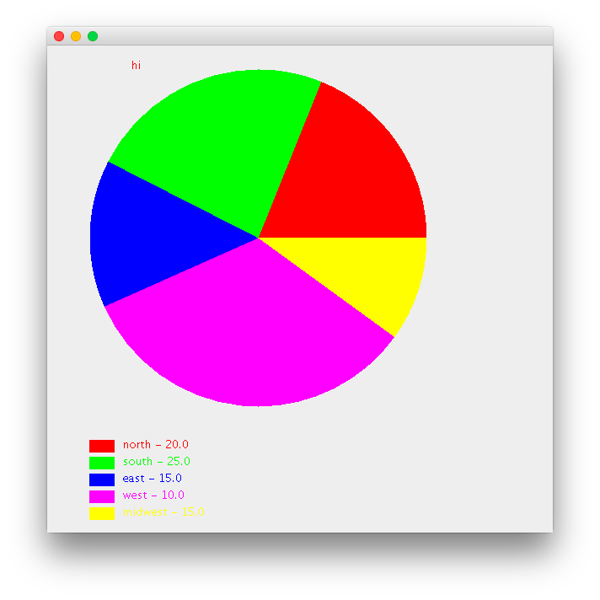

**public** **class** Main {

**public** **static** **void** main(String[] args) {

**double** north = 20;

**double** south = 25 ;

**double** east = 15;

**double** west = 35;

**double** midWest = 10;

//constructor

JFrameExt f = **new** JFrameExt(north,south,east,west,midWest);

f.setSize(600,600);

f.setVisible(**true**);

}

}

**import** java.awt.Color;

**import** java.awt.Graphics;

**import** java.awt.HeadlessException;

**import** javax.swing.JFrame;

**public** **class** JFrameExt **extends** JFrame{

**private** **double** n;

**private** **double** s;

**private** **double** e;

**private** **double** w;

**private** **double** mw;

**public** JFrameExt(**double** n, **double** s, **double** e, **double** w, **double** mw) **throws** HeadlessException {

**super**();

**this**.n = n;

**this**.s = s;

**this**.e = e;

**this**.w = w;

**this**.mw = mw;

}

//public JFrameExt(double n, double s, double e, double w, double mw) {

//what does override do

@Override

**public** **void** paint (Graphics g){ //paint method

**super**.paint(g); //clearn up

**double** total;

total = n+s+e+w+mw;

// g.drawString("hi", 100, 50); //down movement, right movement

//g.drawRect(50, 50, 400, 200); //g.drawRect(x,y,wid,hight) , draw rectangle shape

//g.drawOval(50,50,400,200); //this is the ellipse inside the rectnale, then

g.setColor(Color.***red***);

**int** startAngle = 0 ;

**int** arcWidth = 0;

g.setColor(Color.***red***);

startAngle = startAngle + arcWidth;

arcWidth = (**int**) (n/total * 360); //casting (int)

g.fillArc(50,50,400,400,startAngle,arcWidth); //default methods provided. drawVariable(), fill()

g.setColor(Color.***green***);

startAngle = startAngle+ arcWidth ;

arcWidth = (**int**) (s/ total * 360);

g.fillArc(50, 50, 400, 400, startAngle, arcWidth);

g.setColor(Color.***blue***);

startAngle = startAngle + arcWidth ;

arcWidth = (**int**) (e/ total * 360);

g.fillArc(50, 50, 400, 400, startAngle, arcWidth);

g.setColor(Color.***magenta***);

startAngle = startAngle+ arcWidth ;

arcWidth = (**int**) (w/ total * 360);

g.fillArc(50, 50, 400, 400, startAngle, arcWidth);

g.setColor(Color.***yellow***);

startAngle = startAngle + arcWidth ;

arcWidth = (**int**) (mw/ total * 360);

g.fillArc(50, 50, 400, 400, startAngle, arcWidth);

//legends marking

g.setColor(Color.***red***);

g.drawString("hi", 100, 50);

g.setColor(Color.***red***);

//g.fillRect(x, y, width, height);

g.fillRect(50,490, 30, 15);

//g.drawString(str, x, y);

g.drawString("north - 20.0", 90, 500);

g.setColor(Color.***green***);

g.fillRect(50,510, 30, 15);

g.drawString("south - 25.0", 90, 520);

g.setColor(Color.***blue***);

g.fillRect(50,530, 30, 15);

g.drawString("east - 15.0", 90, 540);

g.setColor(Color.***magenta***);

g.fillRect(50,550, 30, 15);

g.drawString("west - 10.0", 90, 560);

g.setColor(Color.***yellow***);

g.fillRect(50,570, 30, 15);

g.drawString("midwest - 15.0", 90, 580);

}

}